Date: 30/09/2023 Project ID: Proj_223333_Team_2

Project Title: **TRAFFIC MANAGEMENT**

**PROBLEM DEFINITION**

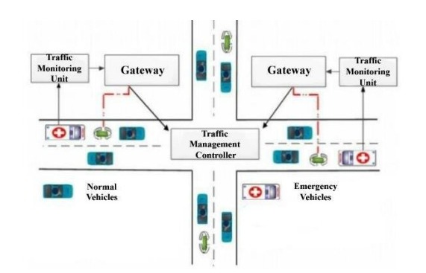Over several decades, traffic congestion has become a serious problem in the major cities. Congestion is particularly associated with motorization and the diffusion of the automobile, which has increased the demand for transportation infrastructure. However, the supply of the transportation infrastructure has often not been able to keep up with the growth of mobility.

**ADVANTAGES OF TRAFFIC MANAGEMENT**

1. Priority based traffic clearance

2. Ambulance detection using Image processing

3. Safety message display on LCD

4. Red Signal break (Number plate detection)

5. If any obstacle in any particular lane then display ALERT message on LCD

**REQUIREMENTS**

**Video image Processing System:**

It allows the user to define a limited number of linear detection zones on the roadway in the field-of-view of the video camera.

**Time and Speed table updating System:**

Timetable and speed table updating system stores all estimated travel times and traffic mean speeds related to each route in previous days. A new time table and speed table with up dated data will be created every 20 seconds